  - WILS PRESENTS
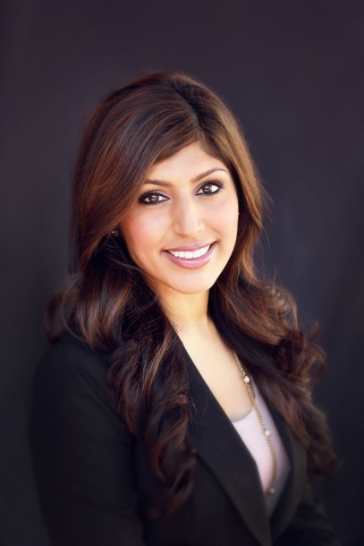
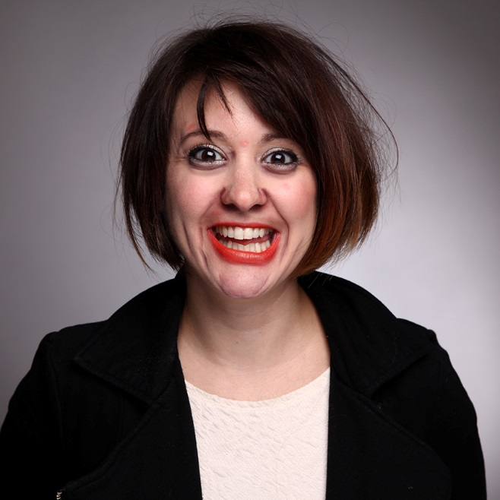

HaPPY HOUR and HEADSHOTS!
upgrade from…
Pitiful to Professional

Friday, May 18 4PM-6PM
The Beer Market
888 N Meacham Rd, Schaumburg, IL 60173
Join us for networking and headshots! Price will include two drink tickets and light appetizers. See below for price breakouts. Headshots will be done by
Christy Pamero www.christinamariephoto.com.

Member Happy Hour: $10.00 / Non-Member: $20.00
Members Happy Hour and Headshot: $30.00 / Non Member: $45

asdf

www.christinamariephoto.com
See you there!

